## **1**

## **Objectives**

* Define SPA and its benefits
* Define React and identify its working
* Identify the differences between SPA and MPA
* Explain Pros & Cons of Single-Page Application
* Explain about React
* Define virtual DOM
* Explain Features of React

In this hands-on lab, you will learn how to:

* Set up a react environment
* Use create-react-app

## **Prerequisites**

The following is required to complete this hands-on lab:

* Node.js
* NPM
* Visual Studio Code

## **Notes**

Estimated time to complete this lab: **30 minutes.**

Create a new React Application with the name “myfirstreact”, Run the application to print “welcome to the first session of React” as heading of that page.

1. To create a new React app, Install Nodejs and Npm from the following link:

<https://nodejs.org/en/download/>

1. Install Create-react-app by running the following command in the command prompt:



1. To create a React Application with the name of “myfirstreact”, type the following command:



1. Once the App is created, navigate into the folder of myfirstreact by typing the following command:



1. Open the folder of myfirstreact in Visual Studio Code
2. Open the App.js file in Src Folder of myfirstreact
3. Remove the current content of “App.js”
4. Replace it with the following:

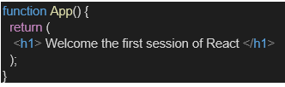

1. Run the following command to execute the React application:



1. Open a new browser window and type “localhost:3000” in the address bar

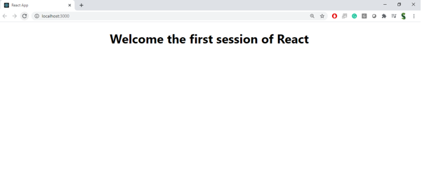

**Code:**

**App.js:**

import './App.css';

function App() {

  return (

    <div>

      <h1>Welcome to the first session of React</h1>

    </div>

  );

}

export default App;

**Output**: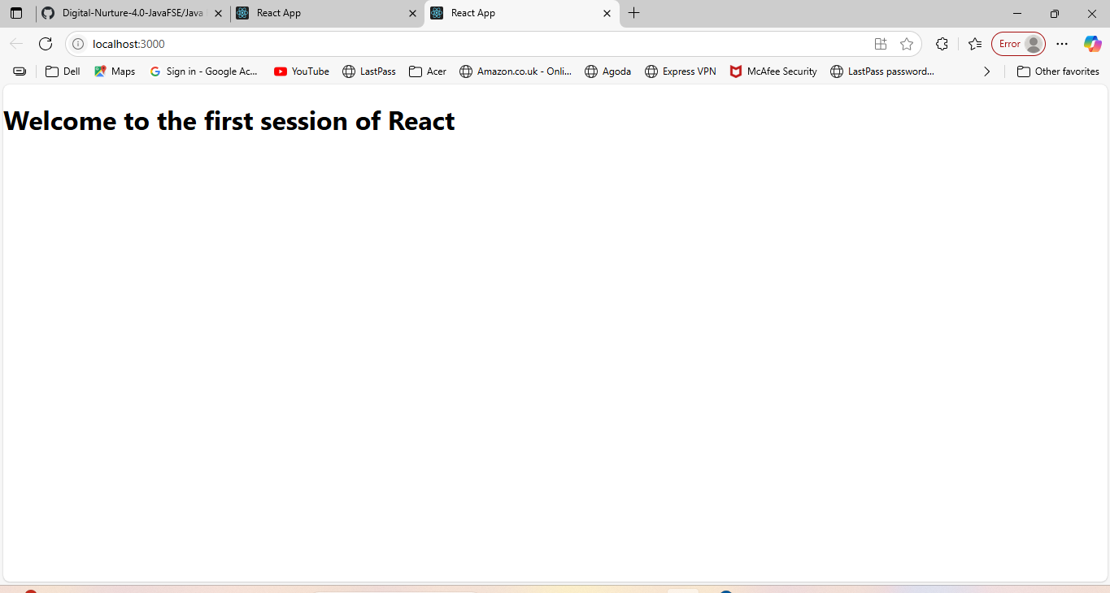

**2:**

## **Objectives**

* Explain React components
* Identify the differences between components and JavaScript functions
* Identify the types of components
* Explain class component
* Explain function component
* Define component constructor
* Define render() function

In this hands-on lab, you will learn how to:

* Create a class component
* Create multiple components
* Render a component

## **Prerequisites**

The following is required to complete this hands-on lab:

* Node.js
* NPM
* Visual Studio Code

## **Notes**

Estimated time to complete this lab: **30 minutes.**

Create a react app for Student Management Portal named StudentApp and create a component named Home which will display the Message “Welcome to the Home page of Student Management Portal”. Create another component named About and display the Message “Welcome to the About page of the Student Management Portal”. Create a third component named Contact and display the Message “Welcome to the Contact page of the Student Management Portal”. Call all the three components.

1. Create a React project named “StudentApp” type the following command in terminal of Visual studio:



1. Create a new folder under Src folder with the name “Components”. Add a new file named “Home.js”
2. Type the following code in Home.js

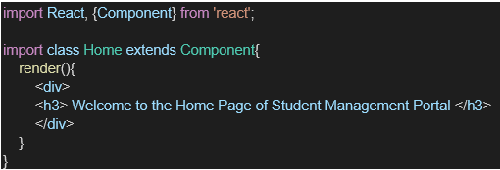

1. Under Src folder add another file named “About.js”
2. Repeat the same steps for Creating “About” and “Contact” component by adding a new file as ”About.js”, “Contact.js” under “Src” folder and edit the code as mentioned for “Home” Component.
3. Edit the App.js to invoke the Home, About and Contact component as follows:

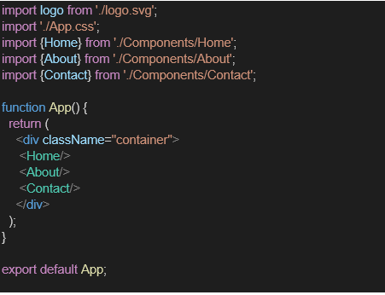

1. In command Prompt, navigate into StudentApp and execute the code by typing the following command:



1. Open browser and type “localhost:3000” in the address bar:

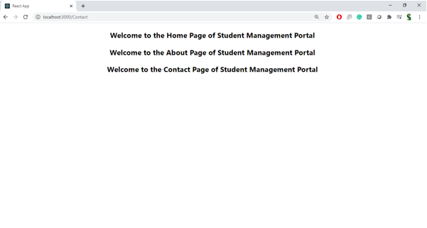

**Code:**

**About.js:**

import React from 'react';

class About extends React.Component {

  render() {

    return (

      <div>

        <h2>Welcome to the About page of the Student Management Portal</h2>

      </div>

    );

  }

}

export default About;

**Contact.js:**

import React from 'react';

class Contact extends React.Component {

  render() {

    return (

      <div>

        <h2>Welcome to the Contact page of the Student Management Portal</h2>

      </div>

    );

  }

}

export default Contact;

**Home.js:**

import React from 'react';

class Home extends React.Component {

  render() {

    return (

      <div>

        <h2>Welcome to the Home page of Student Management Portal</h2>

      </div>

    );

  }

}

export default Home;

**App.js:**

import React from 'react';

import Home from './Components/Home';

import About from './Components/About';

import Contact from './Components/Contact';

function App() {

  return (

    <div className="App">

      <Home />

      <About />

      <Contact />

    </div>

  );

}

export default App;

**Output:**

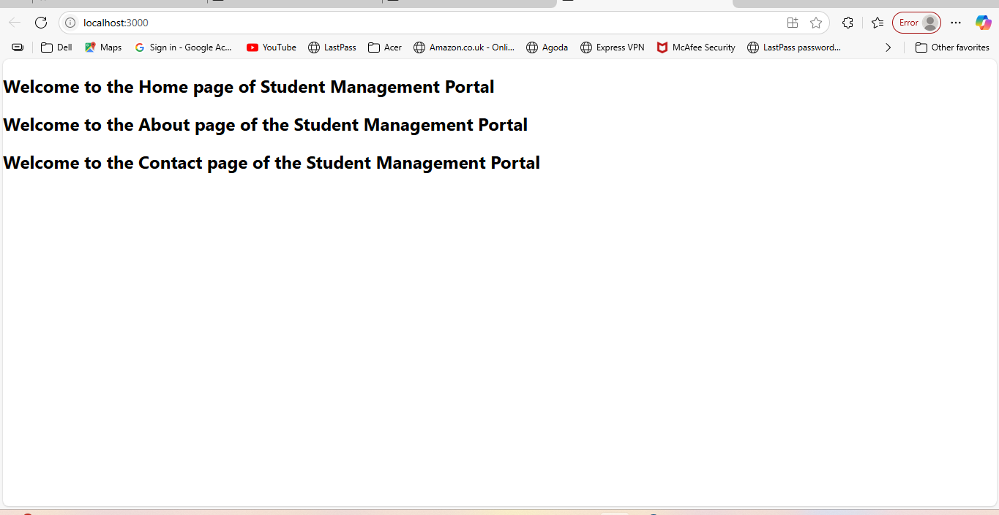

3.

## **Objectives**

* Explain React components
* Identify the differences between components and JavaScript functions
* Identify the types of components
* Explain class component
* Explain function component
* Define component constructor
* Define render() function

In this hands-on lab, you will learn how to:

* Create a function component
* Apply style to components
* Render a component

## **Prerequisites**

The following is required to complete this hands-on lab:

* Node.js
* NPM
* Visual Studio Code

## **Notes**

Estimated time to complete this lab: **30 minutes.**

Create a react app for Student Management Portal named scorecalculatorapp and create a function component named “CalculateScore” which will accept Name, School, Total and goal in order to calculate the average score of a student and display the same.

1. Create a React project named “scorecalculatorapp” type the following command in terminal of Visual studio:



1. Create a new folder under Src folder with the name “Components”. Add a new file named “CalculateScore.js”
2. Type the following code in CalculateScore.js

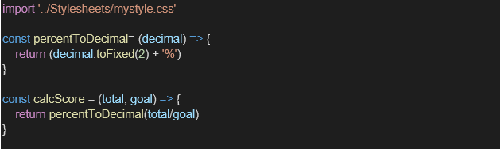

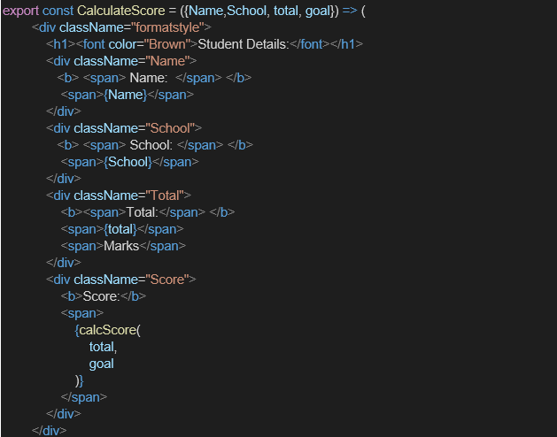

1. Create a Folder named Stylesheets and add a file named “mystyle.css” in order to add some styles to the components:

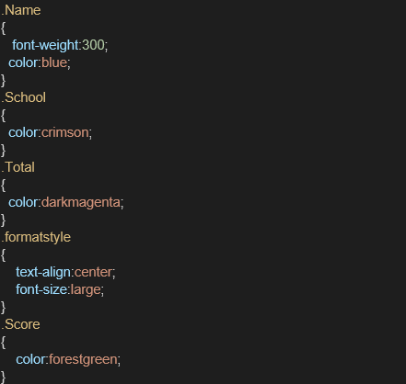

1. Edit the App.js to invoke the CalculateScore functional component as follows:

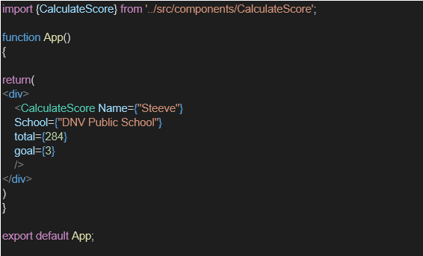

1. In command Prompt, navigate into scorecalculatorapp and execute the code by typing the following command:



1. Open browser and type “localhost:3000” in the address bar:

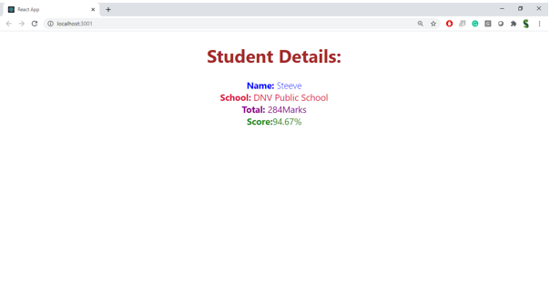

**Code:**

**Calculatescore.js:**

import React from 'react';

import '../Stylesheets/mystyle.css';

function CalculateScore(props) {

  const average = props.total / props.goal;

  return (

    <div className="score-box">

      <h2>Student Score Report</h2>

      <p><strong>Name:</strong> {props.name}</p>

      <p><strong>School:</strong> {props.school}</p>

      <p><strong>Total Score:</strong> {props.total}</p>

      <p><strong>Goal:</strong> {props.goal}</p>

      <p><strong>Average Score:</strong> {average.toFixed(2)}</p>

    </div>

  );

}

export default CalculateScore;

**mystyle.css:**

.score-box {

  border: 2px solid #4CAF50;

  padding: 20px;

  margin: 20px;

  background-color: #f9f9f9;

  border-radius: 10px;

  width: 400px;

  font-family: Arial, sans-serif;

  box-shadow: 2px 2px 10px rgba(0, 0, 0, 0.1);

}

.score-box h2 {

  color: #333;

  text-align: center;

}

**App.js:**

import React from 'react';

import './App.css';

import CalculateScore from './Components/CalculateScore';

function App() {

  return (

    <div className="App">

      <CalculateScore name="Swetha" school="ABC Matric" total={480} goal={6} />

    </div>

  );

}

export default App;

**Output:**

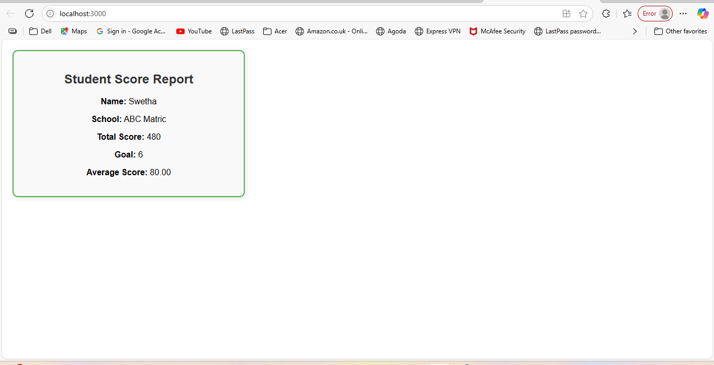

4,

**Objectives**

* Explain the need and Benefits of component life cycle
* Identify various life cycle hook methods
* List the sequence of steps in rendering a component

In this hands-on lab, you will learn how to:

* Implement componentDidMount() hook
* Implementing componentDidCatch() life cycle hook.

## **Prerequisites**

The following is required to complete this hands-on lab:

* Node.js
* NPM
* Visual Studio Code

## **Notes**

Estimated time to complete this lab: **60 minutes.**

1. Create a new react application using *create-react-app* tool with the name as “blogapp”
2. Open the application using VS Code
3. Create a new file named as **Post.js** in **src folder** with following properties

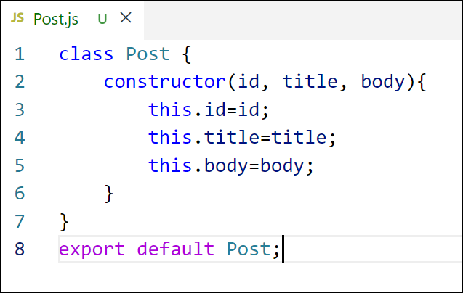

Figure 2: Post class

1. Create a new class based component named as **Posts** inside **Posts.js** file

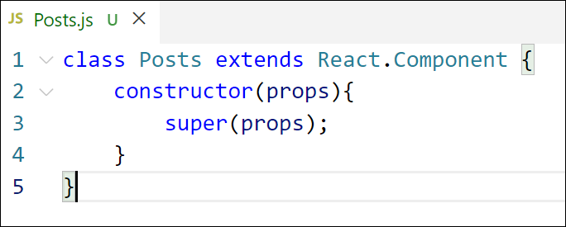

Figure 3: Posts Component

1. Initialize the component with a list of Post in state of the component using the constructor
2. Create a new method in component with the name as **loadPosts()** which will be responsible for using Fetch API and assign it to the component state created earlier. To get the posts use the url (<https://jsonplaceholder.typicode.com/posts>)

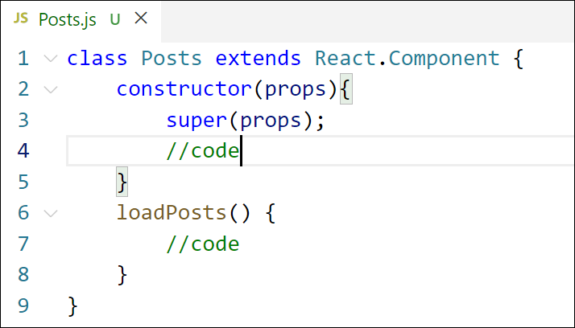

Figure 4: loadPosts() method

1. Implement the **componentDidMount()** hook to make calls to **loadPosts()** which will fetch the posts

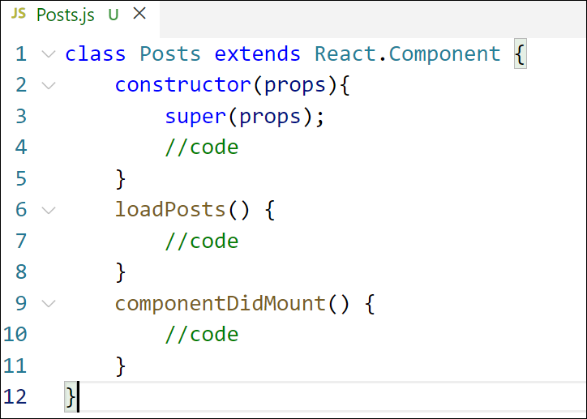

Figure 5: componentDidMount() hook

1. Implement the **render()** which will display the title and post of posts in html page using heading and paragraphs respectively.

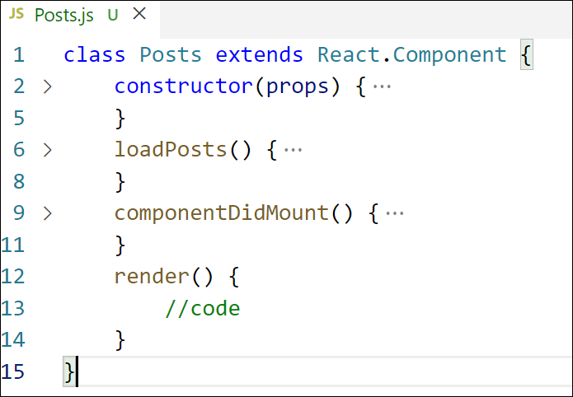

Figure 6: render() method

1. Define a **componentDidCatch()** method which will be responsible for displaying any error happing in the component as alert messages.

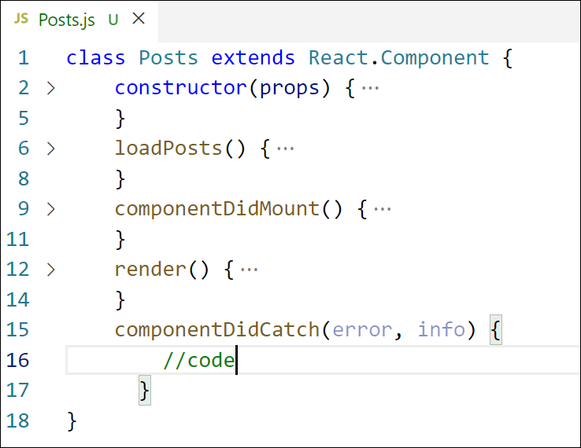

Figure 7: componentDidCatch() hook

1. Add the Posts component to App component.
2. Build and Run the application using *npm start* command.

**Code:**

**Post.js:**

import React from 'react';

function Post(props) {

  return (

    <div style={{ border: "1px solid #ccc", margin: "10px", padding: "10px", borderRadius: "8px" }}>

      <h3>{props.title}</h3>

      <p>{props.body}</p>

    </div>

  );

}

export default Post;

**Posts.js:**

import React, { Component } from 'react';

import Post from './Post';

class Posts extends Component {

  constructor(props) {

    super(props);

    this.state = {

      posts: [

        {

          id: 1,

          title: 'The Importance of Time Management',

          body: 'Time management is key to success. Planning your day helps you prioritize tasks and reduce stress. Effective use of time leads to increased productivity and better results.'

        },

        {

          id: 2,

          title: 'Benefits of Regular Exercise',

          body: 'Exercising regularly improves both physical and mental health. It boosts energy, strengthens the heart, and improves your mood by releasing endorphins.'

        },

        {

          id: 3,

          title: 'Tips for Effective Learning',

          body: 'To learn better, take regular breaks, use active recall, and teach others what you’ve learned. These techniques help retain knowledge longer.'

        },

        {

          id: 4,

          title: 'How to Stay Motivated',

          body: 'Set clear goals and reward yourself for progress. Surround yourself with positivity and break large tasks into smaller, manageable steps to maintain motivation.'

        }

      ],

      hasError: false

    };

  }

  componentDidCatch(error, info) {

    alert("Something went wrong while displaying the posts.");

    console.error("Caught error:", error, info);

    this.setState({ hasError: true });

  }

  render() {

    if (this.state.hasError) {

      return <h2>Error occurred while displaying posts.</h2>;

    }

    return (

      <div>

        <h1>Blog Posts</h1>

        {this.state.posts.map(post => (

          <Post key={post.id} title={post.title} body={post.body} />

        ))}

      </div>

    );

  }

}

export default Posts;

**App.js:**

import React from 'react';

import './App.css';

import Posts from './Posts';

function App() {

  return (

    <div className="App">

      <Posts />

    </div>

  );

}

export default App;

**Output:**

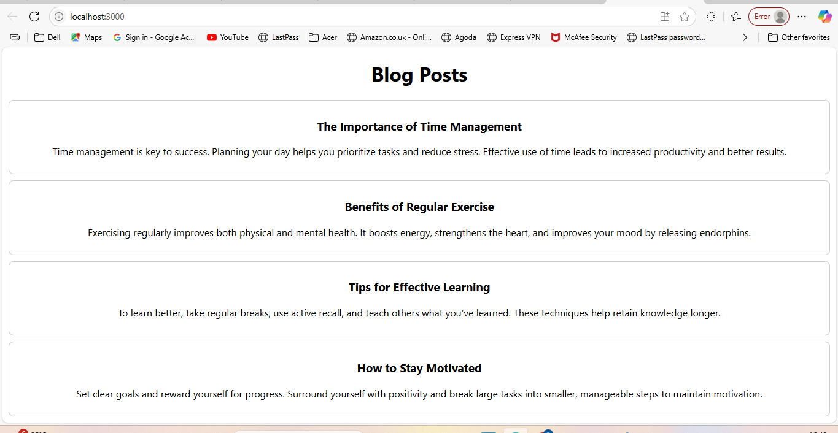

5,

**Objectives**

* Understanding the need for styling react component
* Working with CSS Module and inline styles

In this hands-on lab, you will learn how to:

* Style a react component
* Define styles using the CSS Module
* Apply styles to components using className and style properties

## **Prerequisites**

The following is required to complete this hands-on lab:

* Node.js
* NPM
* Visual Studio Code

## **Notes**

Estimated time to complete this lab: **30 minutes.**

My Academy team at Cognizant want to create a dashboard containing the details of ongoing and completed cohorts. A react application is created which displays the detail of the cohorts using react component. You are assigned the task of styling these react components.

Download and build the attached react application.



1. Unzip the react application in a folder
2. Open command prompt and switch to the react application folder
3. Restore the node packages using the following commands

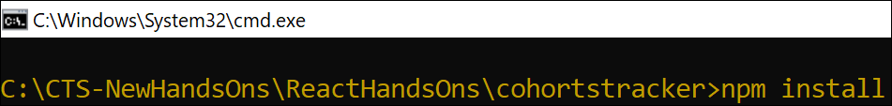

Figure 1: Restore packages

1. Open the application using VS Code
2. Create a new CSS Module in a file called “CohortDetails.module.css”
3. Define a css class with the name as “box” with following properties

*Width = 300px;*

*Display = inline block;*

*Overall 10px margin*

*Top and bottom padding as 10px*

*Left and right padding as 20px*

*1 px border in black color*

*A border radius of 10px*

1. Define a css style for html <dt> element using tag selector. Set the font weight to 500.
2. Open the cohort details component and import the CSS Module
3. Apply the box class to the container div
4. Define the style for <h3> element to use “green” color font when cohort status is “ongoing” and “blue” color in all other scenarios.
5. Final result should look similar to the below image

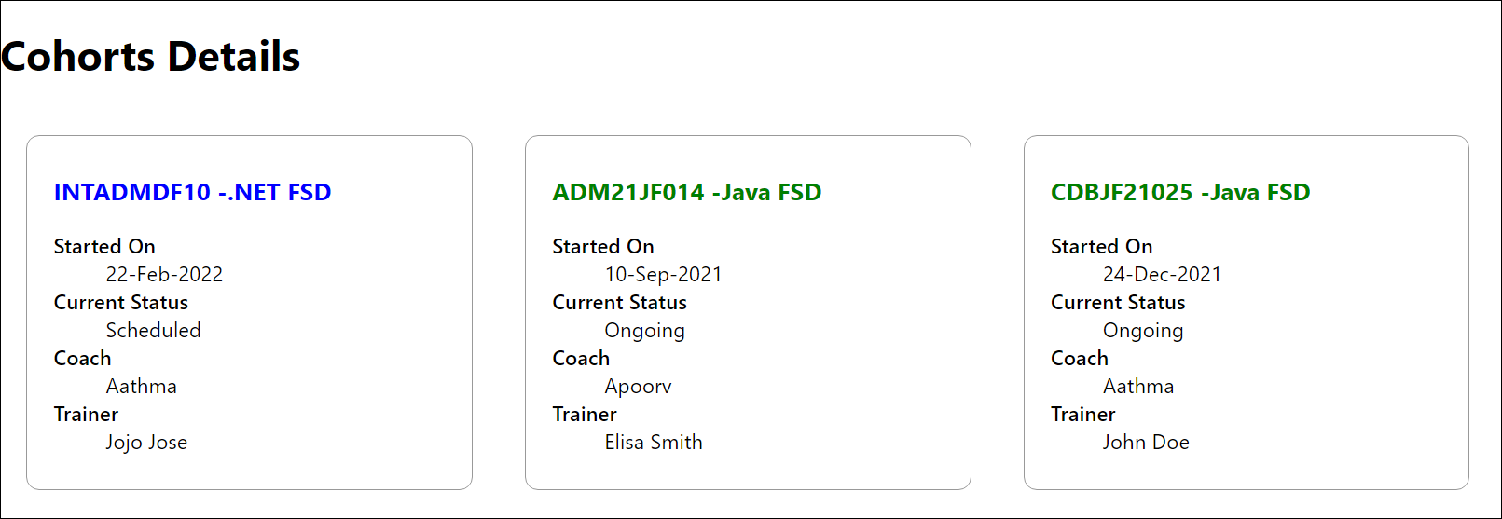

Figure 2: Final Result

**Code**

**App.js:**

import React from 'react';

import './App.css';

import CohortDetails from './CohortDetails';

function App() {

  return (

    <div className="App">

      <CohortDetails name="React Bootcamp" status="ongoing" startDate="2025-06-01" endDate="2025-08-01" />

      <CohortDetails name="Java Fundamentals" status="completed" startDate="2025-03-01" endDate="2025-05-30" />

    </div>

  );

}

export default App;

**CohortDetails.js:**

import React from 'react';

import styles from './CohortDetails.module.css';

function CohortDetails(props) {

  const { name, status, startDate, endDate } = props;

  const headingStyle = {

    color: status === 'ongoing' ? 'green' : 'blue'

  };

  return (

    <div className={styles.box}>

      <h3 style={headingStyle}>{name}</h3>

      <dl>

        <dt>Status:</dt>

        <dd>{status}</dd>

        <dt>Start Date:</dt>

        <dd>{startDate}</dd>

        <dt>End Date:</dt>

        <dd>{endDate}</dd>

      </dl>

    </div>

  );

}

export default CohortDetails;

**CohortDetails.module.css:**

.box {

  width: 300px;

  display: inline-block;

  margin: 10px;

  padding: 10px 20px;

  border: 1px solid black;

  border-radius: 10px;

}

dt {

  font-weight: 500;

}

**Output:**

